HOW TO LIVE STREAM USING OFFICE 365 STREAM AND OBS

Software Needed:

- OBS - download at obsproject.com
- Microsoft Office Stream

Hardware Needed: Windows or Mac computer with audio and video (or external webcam and microphone)

One Time Setup:

- Create a Channel in Microsoft Office Stream
  - In the Stream navigation bar, go to Create > Create a channel.
  - In the Create Channel page, type a unique name and description for your channel.
  - Make sure you choose Companywide Channel for Channel Access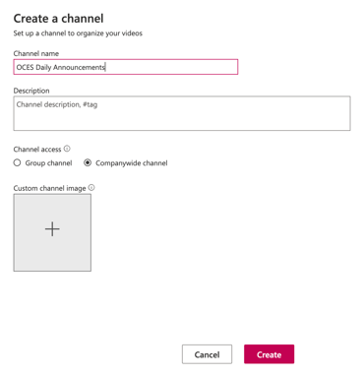

- Download OBS software from obsproject.com

Procedure:

- Log in to Office 365 and access the Stream app. Click All Apps if you don’t see it.

- Click + next to Create and then Live Event.
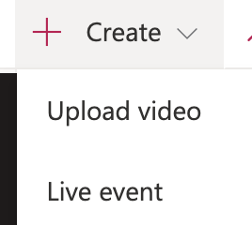

- Enter a unique name.

- Next to Start Event – Choose As soon as encoder is connected (now)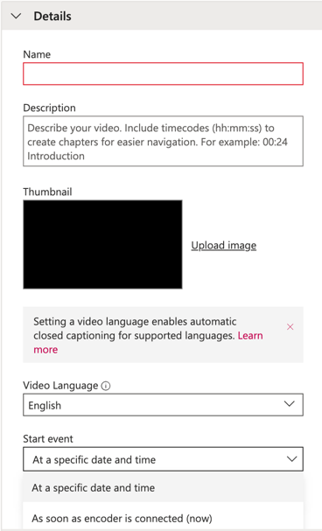

- Under Permissions
  - Share with – select Channels
  - Search for and select your channels
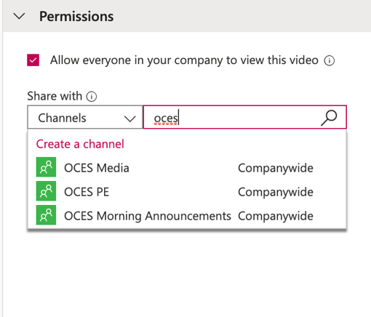

- Under Options – turn off Comments and Autogenerate captions
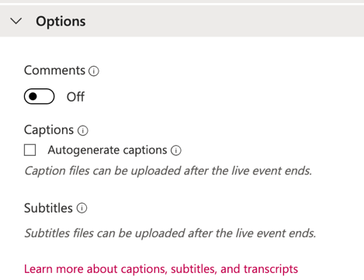

- Click Publish.
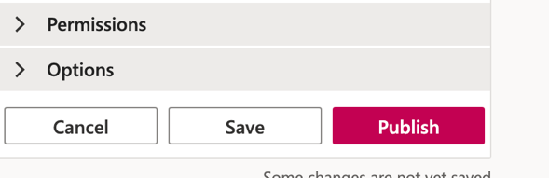

- Click Start Setup on the bottom right of the video screen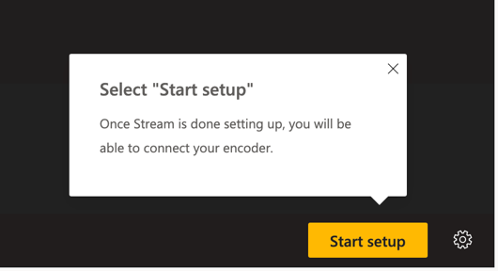

- Scroll down until you see the Server ingest URL. Click Copy.
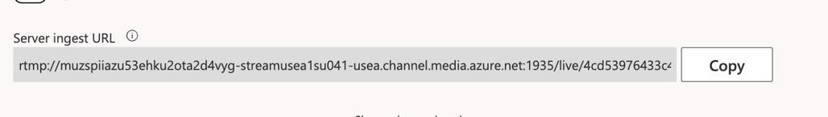

- Go to OBS.

- Click on Settings on the bottom right.
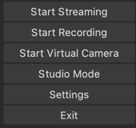

- Click on Stream in the left hand menu.
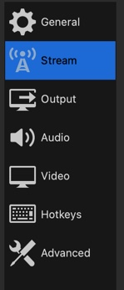

- Paste the URL code you copied from Stream in the box called Server.

- Enter the stream key: 192837465. You only need to enter this the very first time you set up a live stream.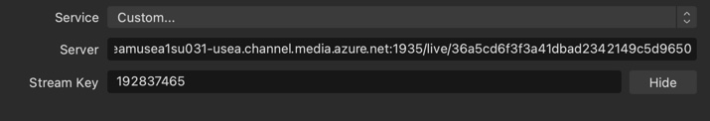

- Click OK.

- Under Sources, click the + and select Video Capture.
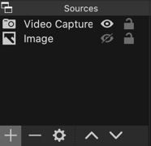

- Click Start Streaming in the right-hand menu.
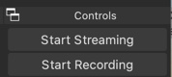

- Once it has connected (you will see Stop Streaming as an option), go back to Stream.

- Wait until you see You’re ready to go live. Once you see this, click Start event. It will take up to a minute until you see this message so be patient.
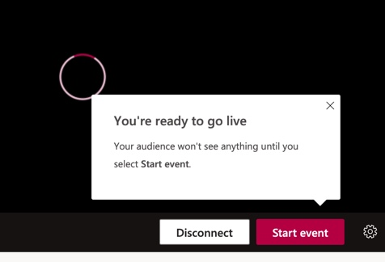

- Go back to OBS so you can see the live video streaming.

- When your live stream is over, in OBS click Stop Streaming.
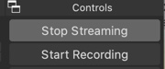

- Go back to Stream and click End event.
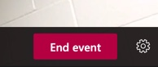

- Trim your video if necessary.

- Your live stream will now appear in your channel.

Note: there is about a minute delay between what you are streaming and what others are viewing in Stream.

