ADD A XEROX PRINTER TO YOUR MACBOOK

- Open System Preferences (either on your Dock or from the Apple Menu).
- Click Printers & Scanners.
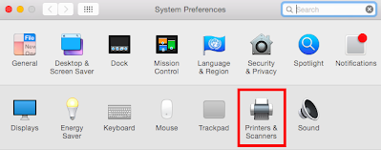

- Click on the + sign (lower left) to add a printer.
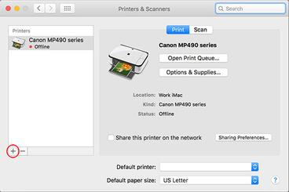

- Click the button then enter the IP address of the Xerox you want to add in the Address box.
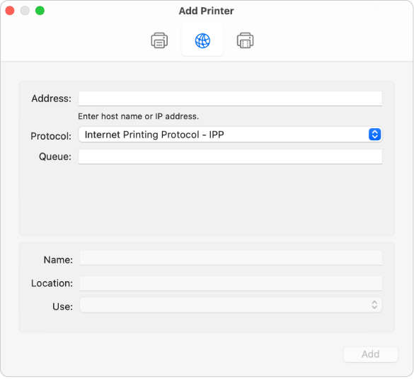

- Rename the printer (optional).

- Click Add in bottom right corner to add the Xerox printer.

